Manner Adjunct

✅ What Is a Manner Adjunct?
# Source: AI Source: Provided by: [Data Path: Persons Table -> ID Column: 1, Name_En Column: Motasem Essam] -> From: [Chatgpt (GPT-4-turbo)] on [8/5/2025]
A manner adjunct is a word, phrase, or clause that describes how an action is performed. It gives non-essential, descriptive detail about the style, method, or approach of the action.
It answers the question:
- How?

🔸 Common Forms of Manner Adjuncts:
# Source: AI Source: Provided by: [Data Path: Persons Table -> ID Column: 1, Name_En Column: Motasem Essam] -> From: [Chatgpt (GPT-4-turbo)] on [8/5/2025]
- Adverbs: quickly, carefully, beautifully, badly
- Prepositional Phrases: with care, in silence, like a pro
- Simile Phrases/Clauses: as if he knew nothing, like lightning

🔸 Examples of Manner Adjuncts in Sentences:
# Source: AI Source: Provided by: [Data Path: Persons Table -> ID Column: 1, Name_En Column: Motasem Essam] -> From: [Chatgpt (GPT-4-turbo)] on [8/5/2025]
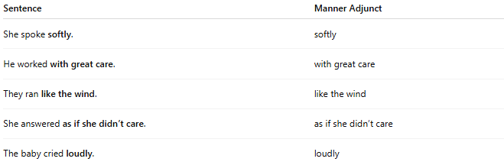
Sentence | Manner Adjunct
She spoke softly. | softly
He worked with great care. | with great care
They ran like the wind. | like the wind
She answered as if she didn’t care. | as if she didn’t care
The baby cried loudly. | loudly

🔸 Position in the Sentence:
# Source: AI Source: Provided by: [Data Path: Persons Table -> ID Column: 1, Name_En Column: Motasem Essam] -> From: [Chatgpt (GPT-4-turbo)] on [8/5/2025]
- Initial: Like a professional, she delivered her speech.
- Medial: She carefully opened the box.
- Final: He completed the test without hesitation.

🔸 Reminder:
# Source: AI Source: Provided by: [Data Path: Persons Table -> ID Column: 1, Name_En Column: Motasem Essam] -> From: [Chatgpt (GPT-4-turbo)] on [8/5/2025]
A manner adjunct adds rich description but is not required for the sentence to be grammatically complete.
🟢 "He ran."
🟡 "He ran like the wind." → Manner adjunct added for style

